Polynomials Functions Name: ____________________________________

Problems 1: Write the equation for the polynomial graph shown. Assume that all even multiplicities are 2 and all odd multiplicities are 3

2) Sketch the graph of the equation with a double root at –2, a single root at 5, a triple root at 0 and a double root at 2. Assume the leading coefficient is negative one. Write the equation of the function that describes the graph.

Equation: ________________________________

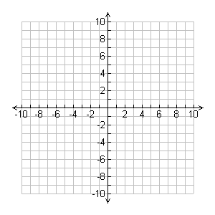
3) Sketch the graph of the equation y = -x(x-1)²

Sketch the graph of each function.

4) f(x) = (x + 1)(x – 2)(x – 4)

5) f(x) = -(x + 3)(x + 2)(x – 1)³

6) f(x) = -x(x + 5)²(x + 3)

7) y = x²(x-3)(x-1)(x+1)

8) y = - x³(x-2)²

9) f(x) = x²(x - 1)²(2 + x)

